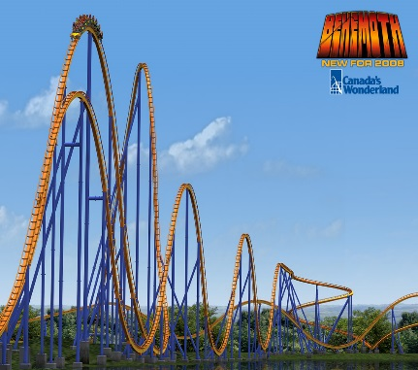One of the newest roller-coasters at Canada’s Wonderland is the “The Behemoth”. It is the Park's first coaster designed by the famed Swiss company Bolliger & Mabillard. It is also the park’s first hyper coaster (a coaster with a height or first drop over 200 feet). The first drop towers at 230 feet (70.1M) – that’s the same height as Drop Tower! It reaches speeds of 125km/hour in 3.9 seconds when it drops riders back to Earth at a 75 degree angle. Trains traverse 5318 feet (1606M) of track taking riders over 4 massive airtime hills, a 180 degree hairpin turn, and 2 helixes. It is one of the best new rides in the world as voted on by Amusement Today readers and other Industry publications and polls when it opened in 2008.

This year they have contracted your team to build an even bigger hyper-coaster based on the following schematic. However, before they can proceed they need to know if this coaster design falls within acceptable speed and safety limits.



Assumptions:

* The ride is frictionless
* The ride holds 80 people
* The mass of the train cars is the same as the mass of the passengers (add them)
* The initial velocity of the train at the top of the first hill is essentially 0 m/s.

Requirements:

1. Find the gravitational potential, kinetic, and total energy of the train at the indicated positions.
2. Find the location and value of the highest speed of the train.

Extra Challenge (Hint: Extra Work)

* Add friction to you calculation and assume the coefficient of friction of the train wheels on the track is 0.0015
* Assume the total length of the track from point A to point F is 1600 m.
* Find the speed of the train at point F

**Basic Solution**

Assumptions:

* Assume average rider has a mass of 60kg.
* Mass of riders: 60kg x 80 riders = 4800 Kg
* Mass of train = mass of riders = 4800 Kg
* Total mass of train & rides = 9600 Kg

Analysis:

Eg = mhg Ek = 1/2 mv2 ET = Eg + Ek

|  |  |  |  |
| --- | --- | --- | --- |
| **Position** | **Eg** | **EK** | **ET** |
| A | h=120m, Eg = 1.13x107J | V=0, Ek = 0J | 1.13x107J |
| B | h=60m, Eg = 5.65x106J | Ek = 5.65 x106J, V = 34.3 | 1.13x107J |
| C | h=0m, Eg = 0J | Ek = 1.13x107J, V = 48.5 m/s | 1.13x107J |
| D | h=?m, Eg = | Ek = 0J, V = | 1.13x107J |
| E | h=40m, Eg = 3.77x106J | Ek = 7.53 x106J, V = 39.6 m/s | 1.13x107J |
| F | h=0m, Eg = 0J | Ek = 1.13x107J, V = 48.5 m/s | 1.13x107J |

**Highest speed is 48.5 m/s (175 km/h) at points C and F.**

**Friction Solution**